1. What is the result of the following code?

* console.log(true && false);
  1. true
  2. false guess [correct]
  3. undefined
  4. null

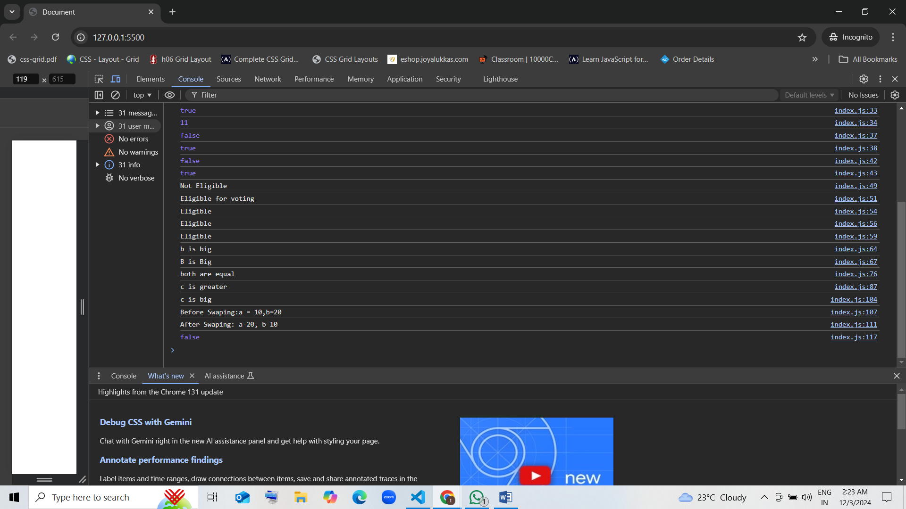

1. What does the following code output?

* console.log(false || true);
  1. true guess [correct]
  2. false
  3. undefined
  4. nul 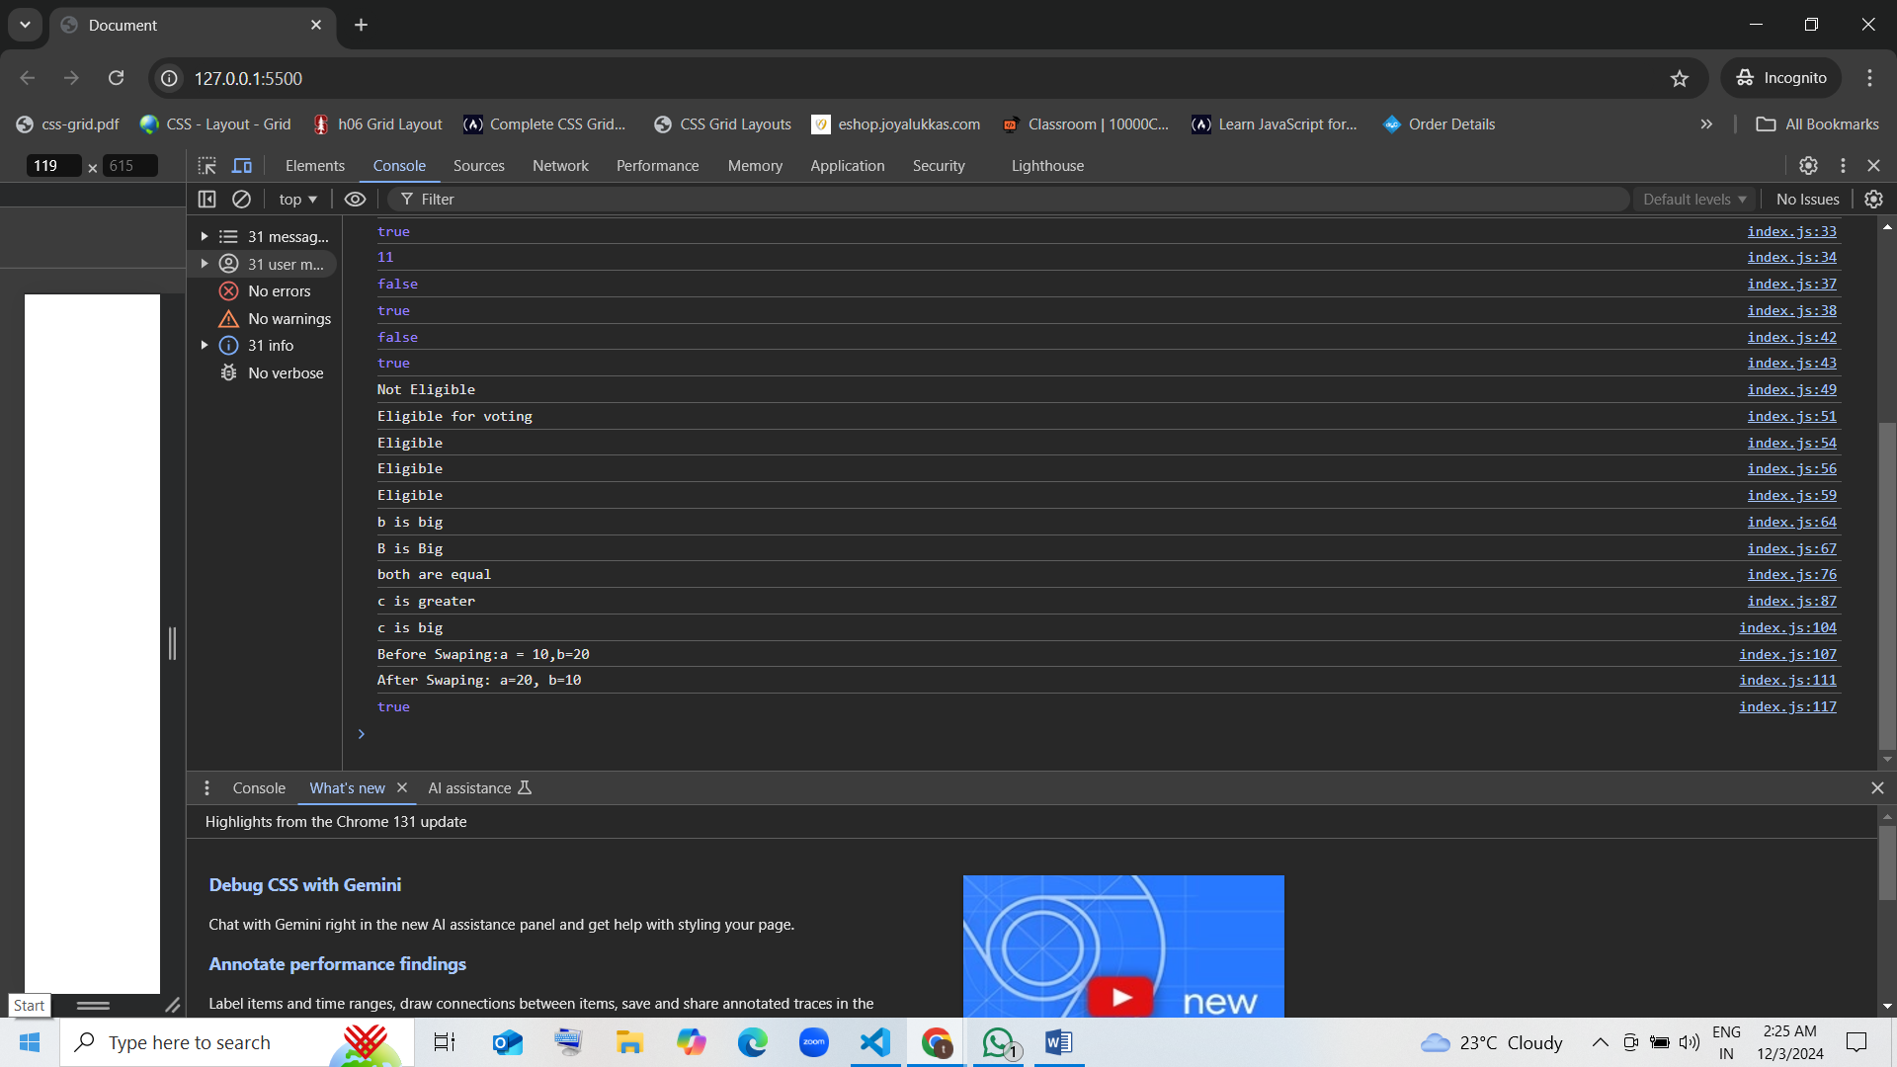

1. What is the value of result?

* const result = !true;  
  console.log(result);
  1. true
  2. false guess [correct]
  3. undefined
  4. null

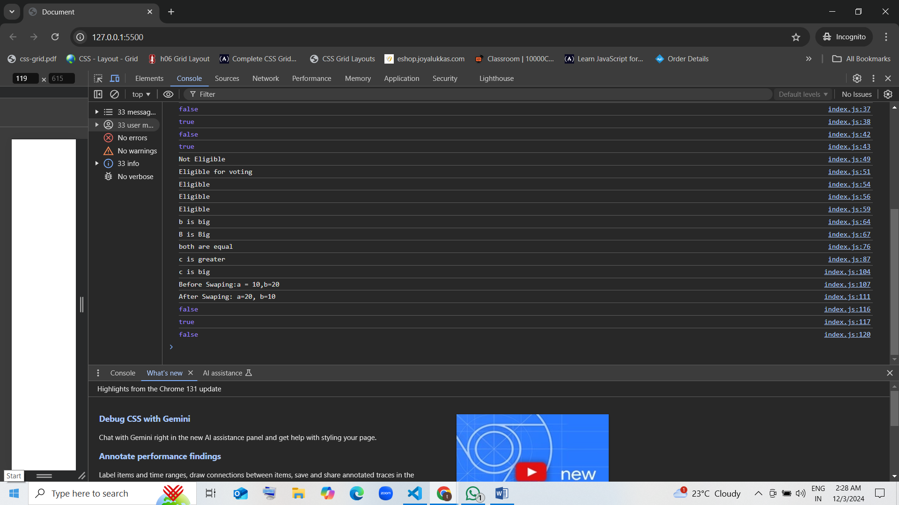

1. What will be logged to the console?

* console.log(10 > 5 && 3 < 4);
  1. true guess [correct]
  2. false
  3. undefined
  4. null

1. What will the following code output?

* console.log(5 === 5 || 5 > 10);
  1. true
  2. false
  3. undefined
  4. null

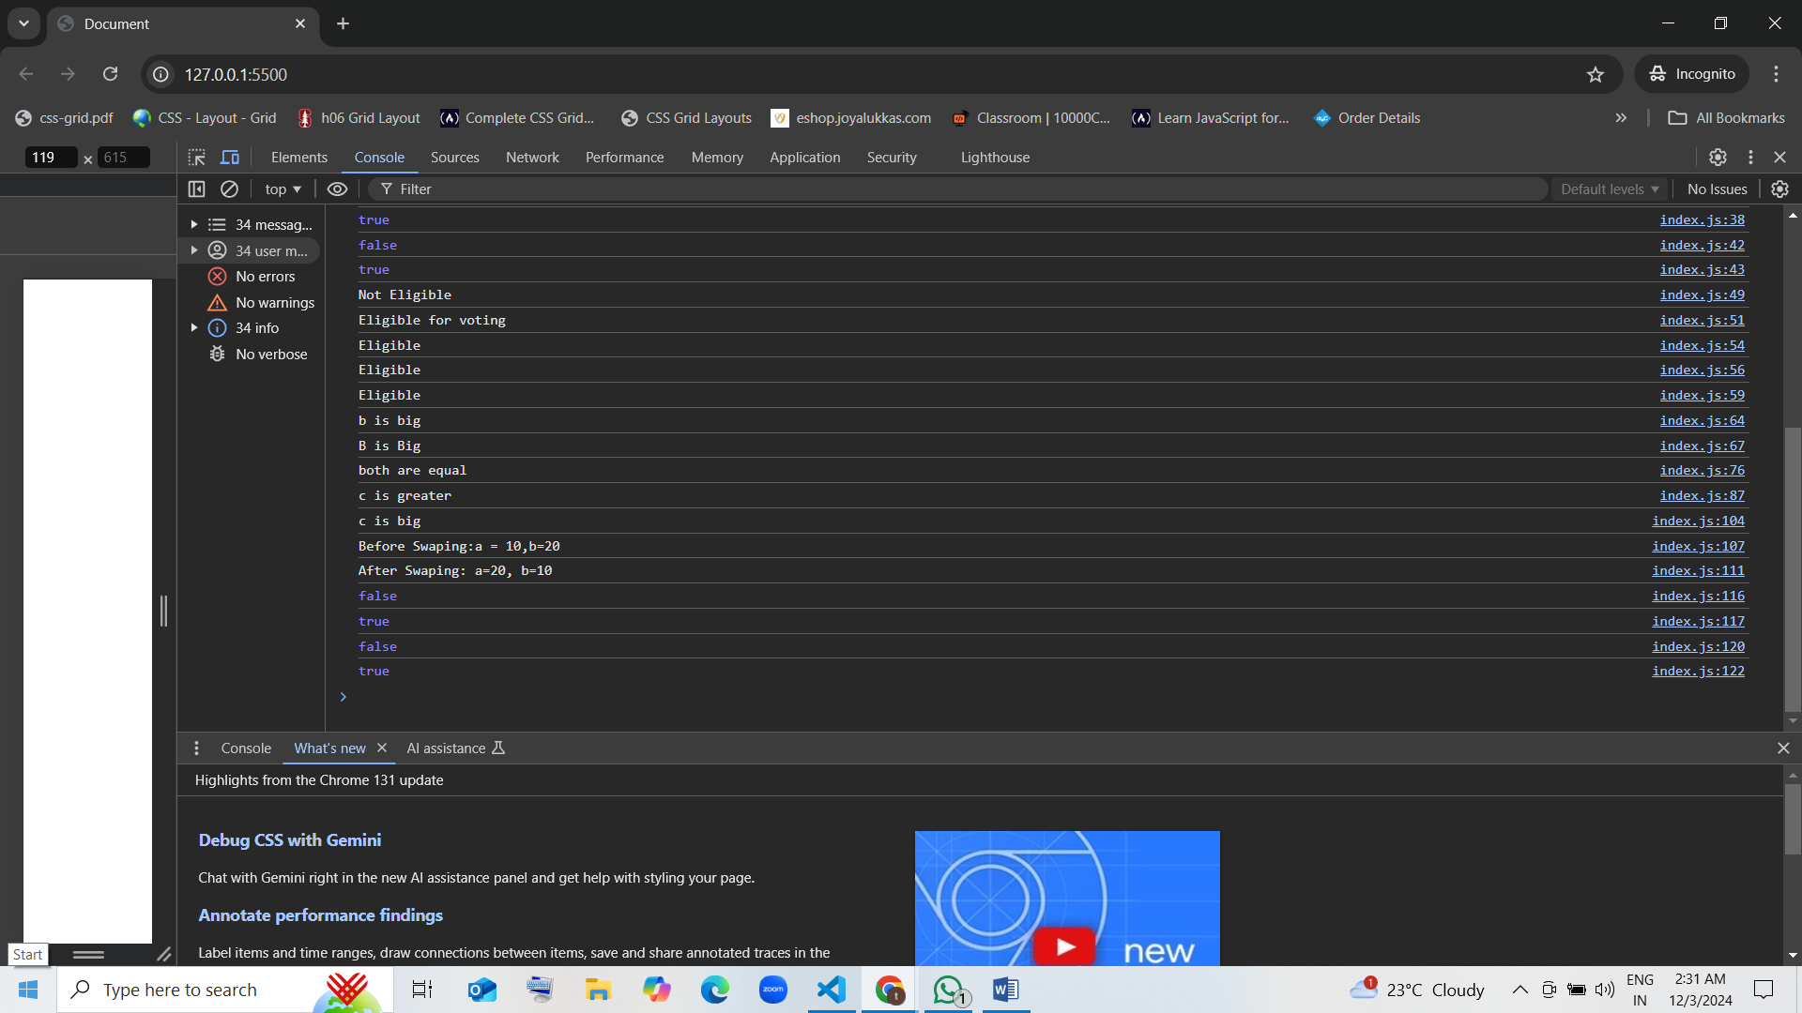

1. What is the result of this code?

* const x = false;  
  const y = true;  
  console.log(x && y || !x);
  1. true guess
  2. false
  3. undefined
  4. null

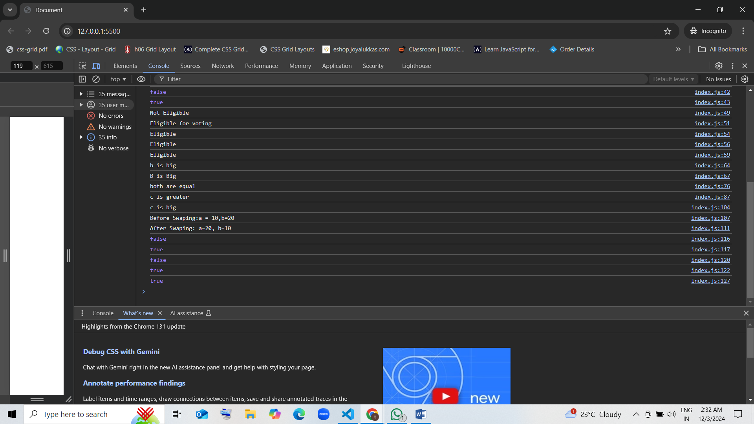

1. What does this code evaluate to?

* console.log(!!(5 > 3));
  1. true [correct]
  2. false
  3. undefined
  4. null guess

1. What will result be?

* const result = false || 0 || "hello";  
  console.log(result);
  1. false
  2. 0
  3. "hello"
  4. Undefined

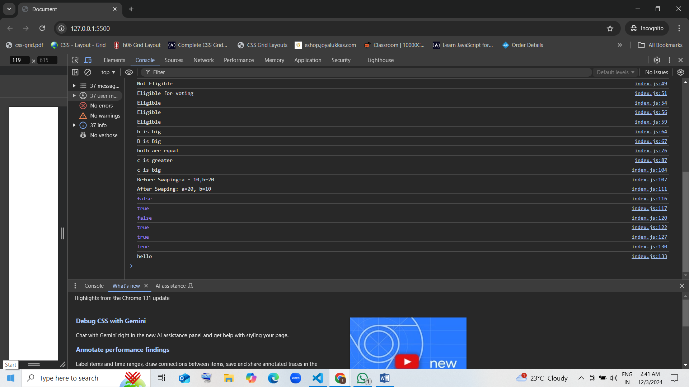

1. What will the following code return?

* console.log(null && "JavaScript");
  1. null guess [correct]
  2. "JavaScript"
  3. true
  4. false

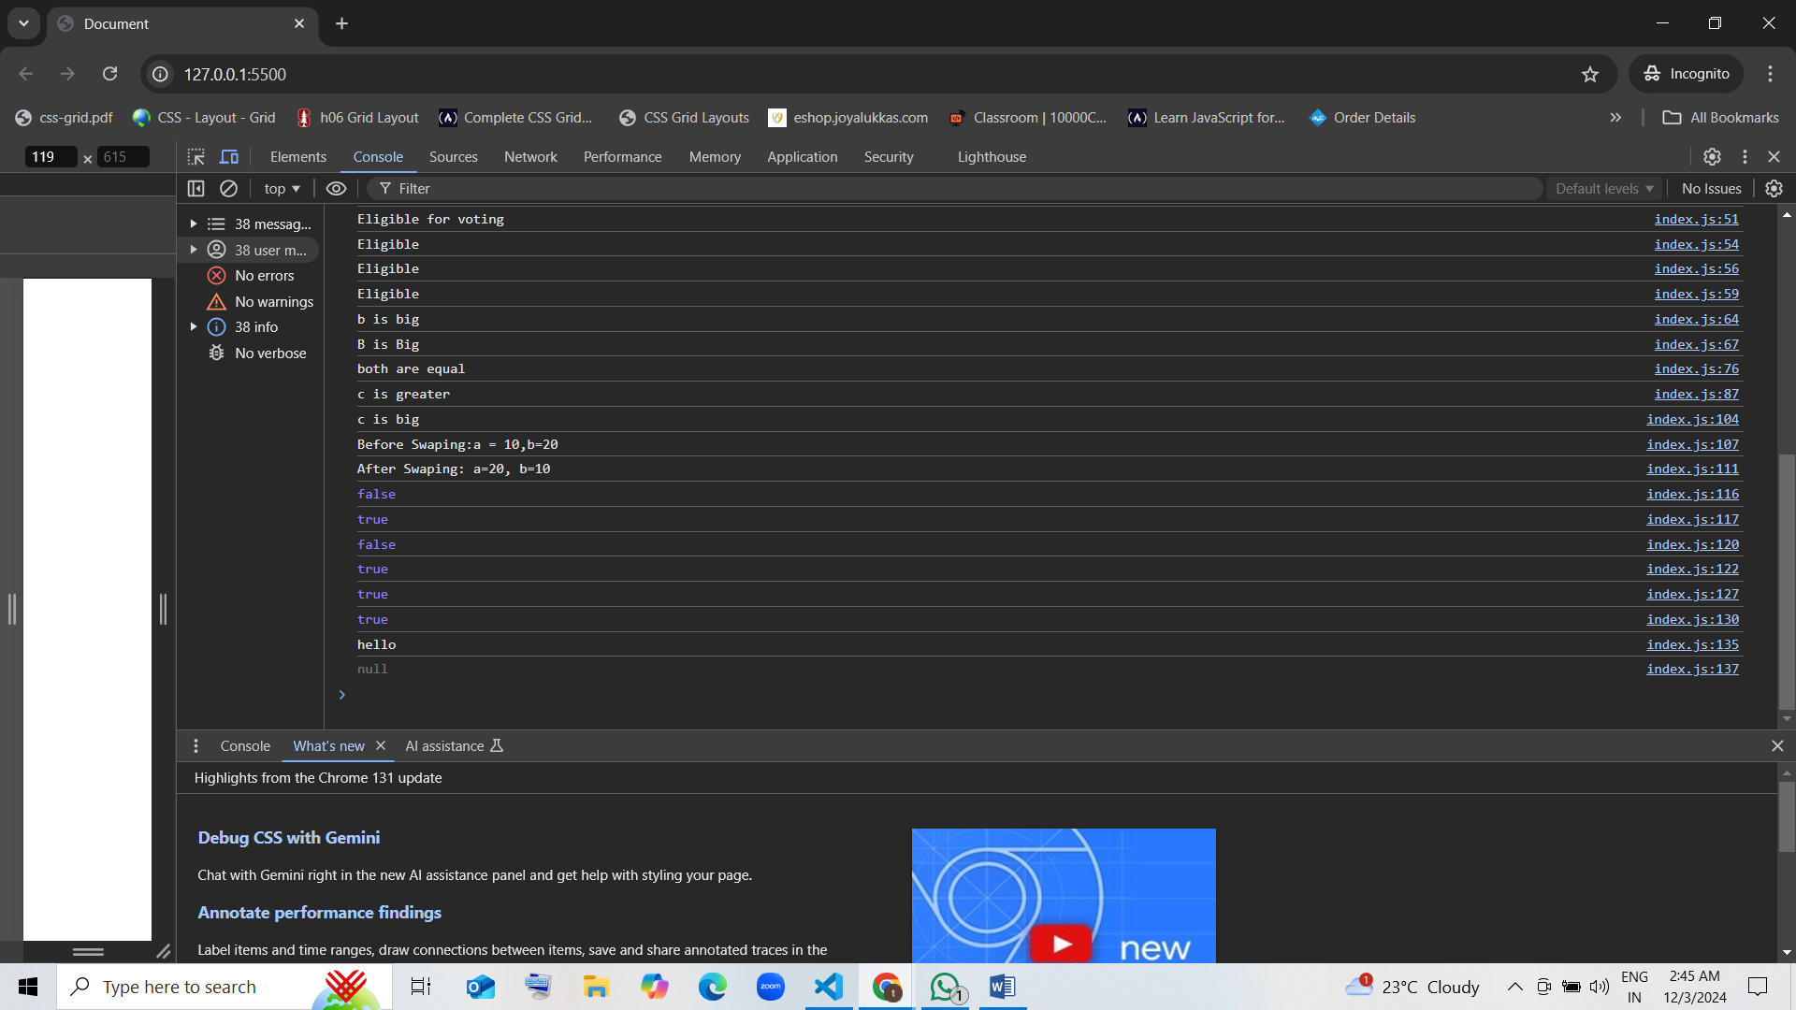

1. What does this code output?  
   console.log(true || false && false);
   1. True guess [correct]
   2. false
   3. undefined
   4. null

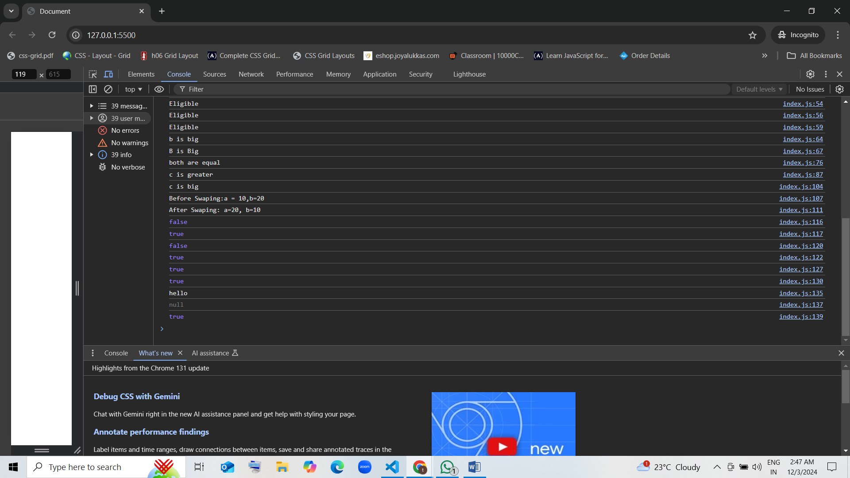

1. What is the result of the following expression?  
   console.log(!("hello" && 0));
   1. True guess [correct]
   2. false
   3. null
   4. undefined

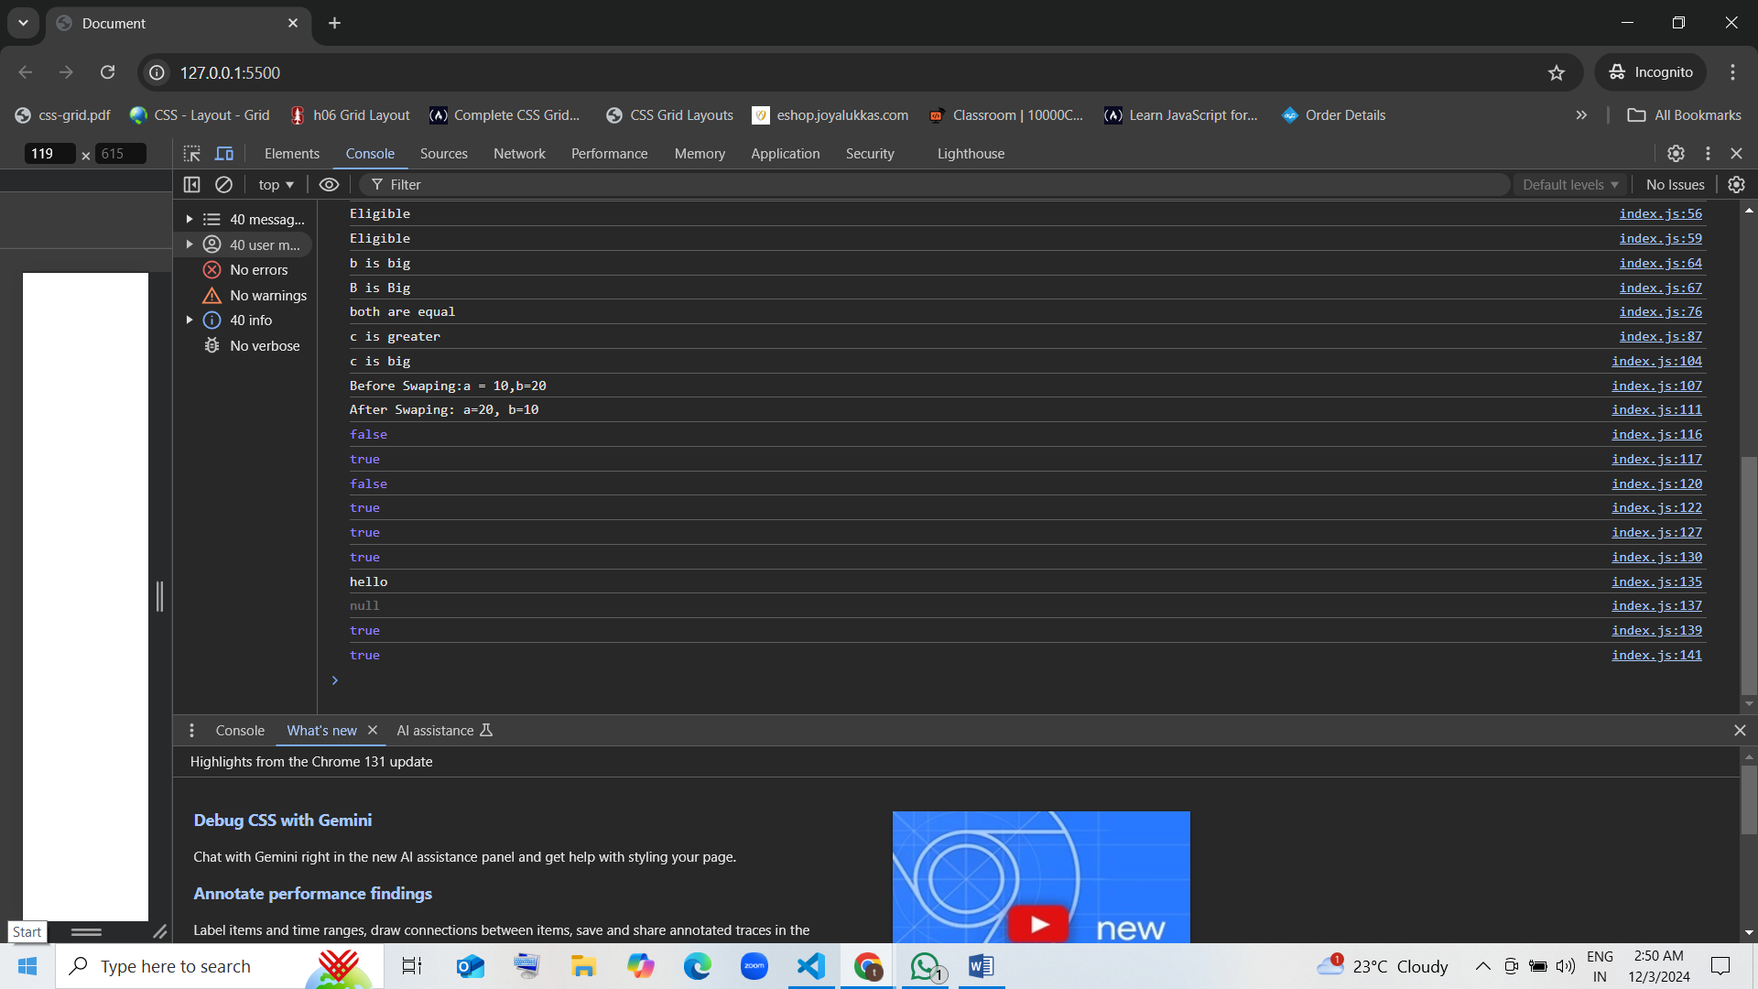

1. What will be logged?  
   console.log(10 || 0 && 5);
   1. 10 guess [correct]
   2. 0
   3. 5
   4. false
2. What will result be?  
   const result = "abc" && "def" || "";

console.log(result);

* 1. "abc"
  2. "def"
  3. ""
  4. Undefined

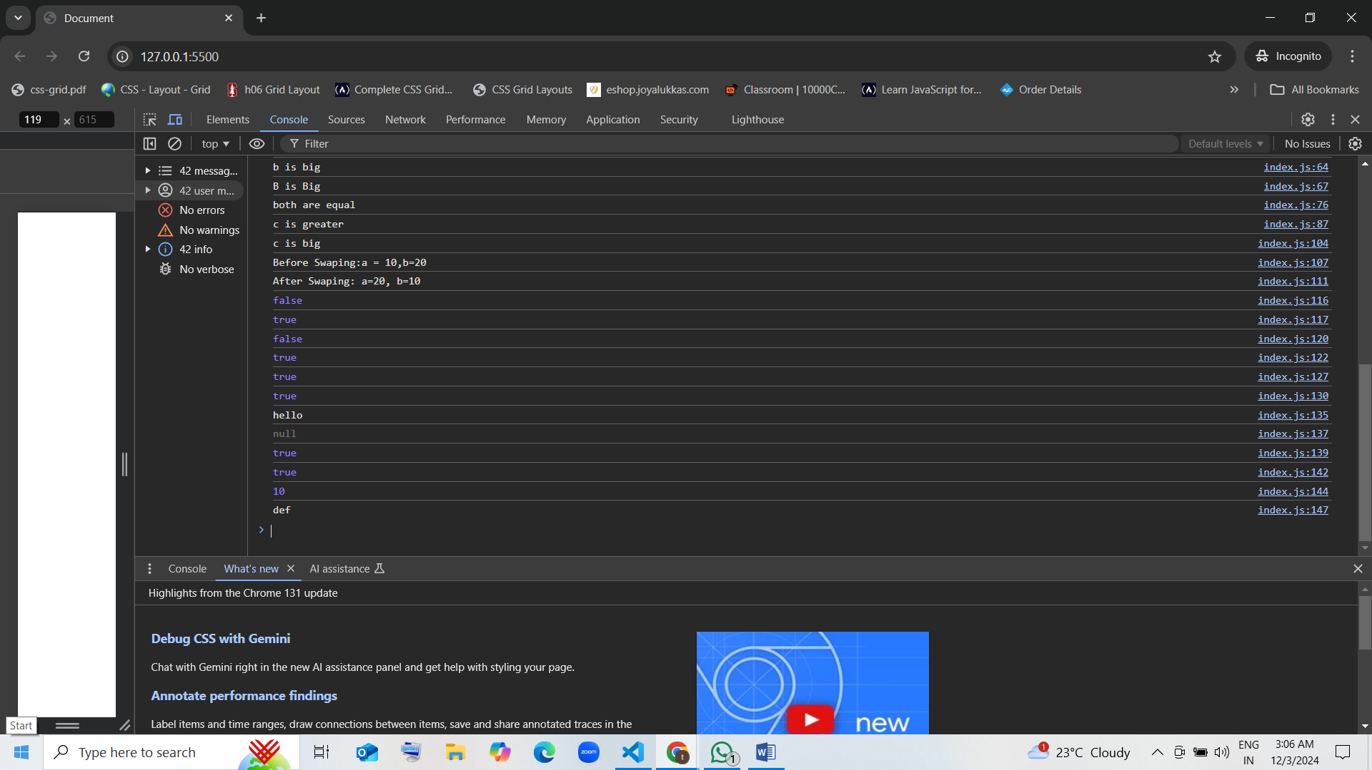

1. What does this code evaluate to?  
   console.log(3 > 2 && 2 > 4);
   1. true
   2. false guess
   3. undefined
   4. null

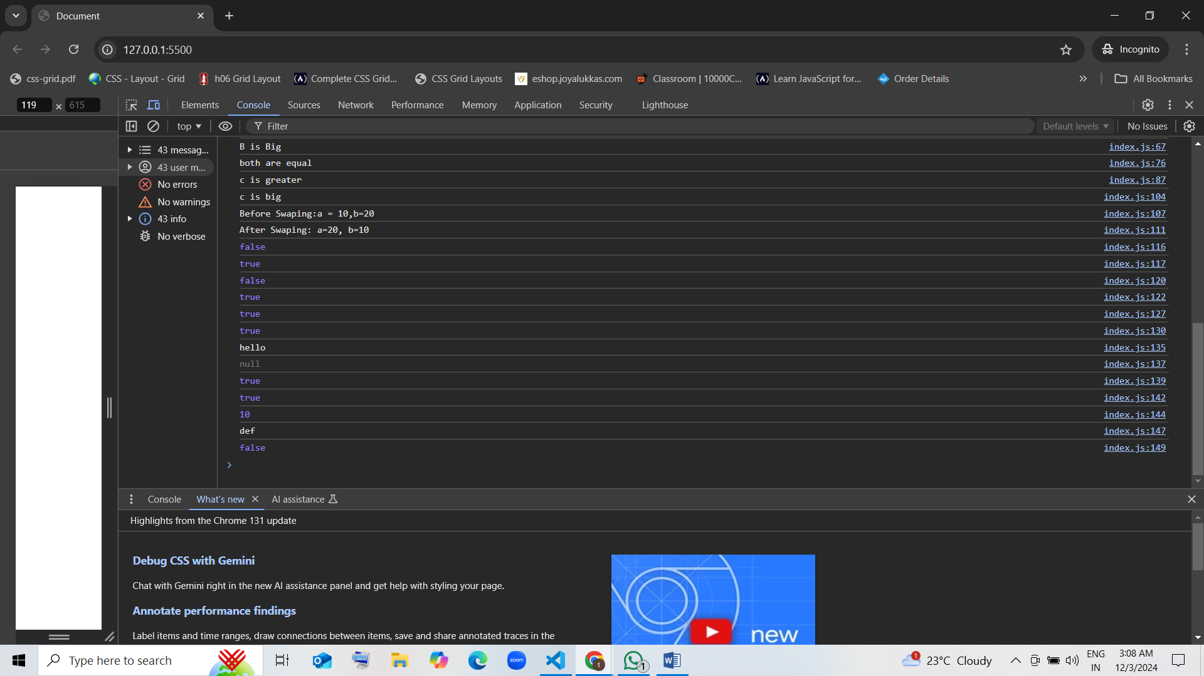

1. What will the following code return?  
   console.log(false || NaN || undefined);
   1. false
   2. NaN
   3. Undefined [correct]
   4. null

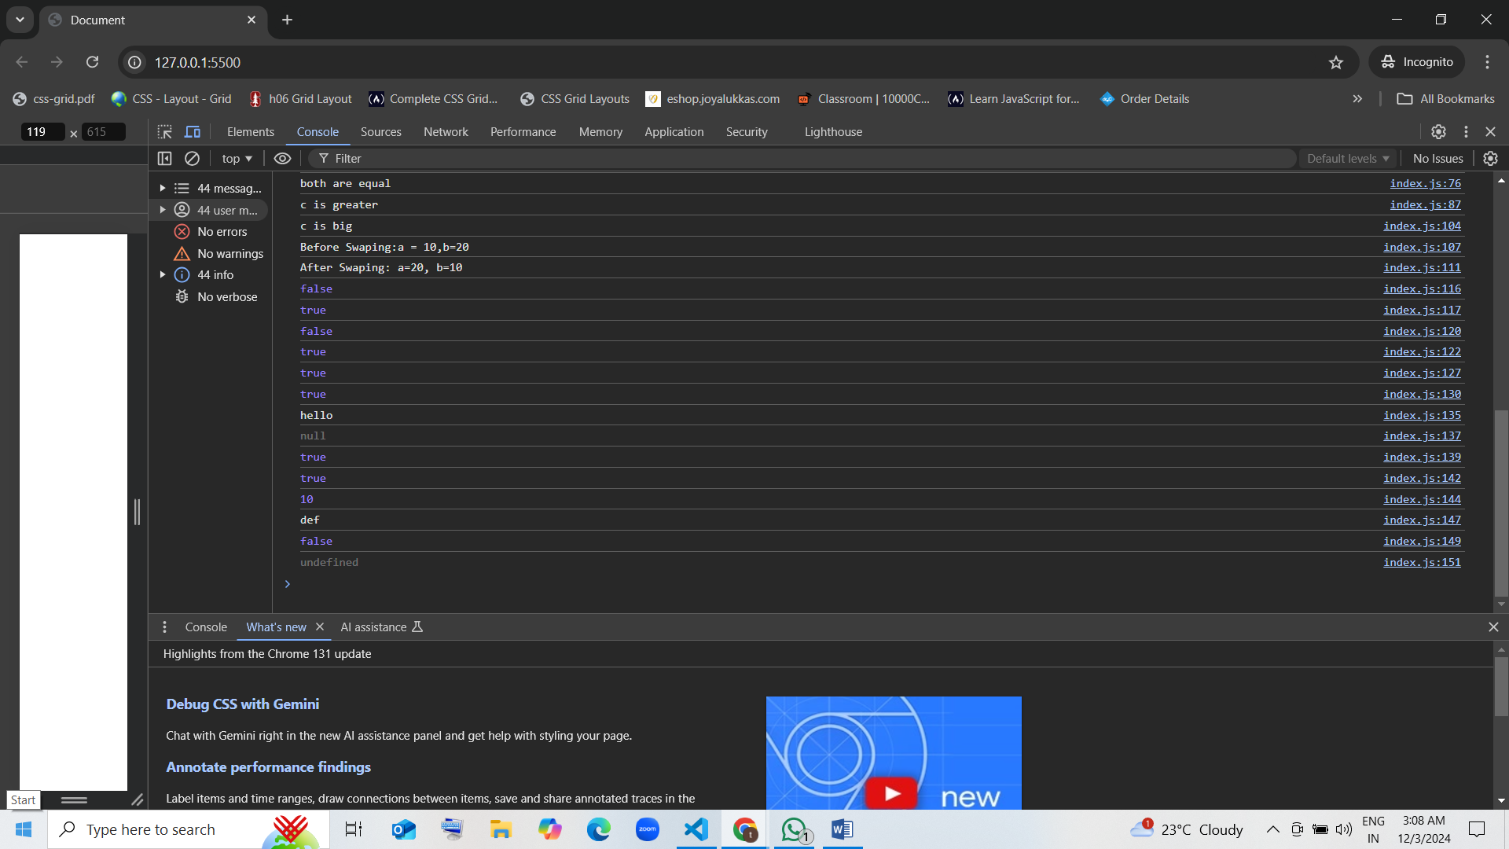

**#scenario-based questions**

### 1. Eligibility Check

Write a condition to check if a student is eligible for a scholarship. The criteria are:  
- The student’s grade is A or B.  
- The student’s attendance is above 75%.  
Use a ternary operator to assign "Eligible" or "Not Eligible" to a variable.

### 2. Age Group Classification

Classify a person based on their age:  
- If the age is less than 13, they are a “Child”.  
- If the age is between 13 and 19 (inclusive), they are a “Teenager”.  
- Otherwise, they are an “Adult”.  
Use nested ternary operators to determine the classification.

### 3. Login Status

Check the login status of a user. A user is considered logged in if:  
- isLoggedIn is true.  
- Their session is active (sessionActive is true).  
Use a ternary operator to log "Welcome Back" if the user is logged in and "Please Log In" otherwise.

### 4. Grade Evaluation

Assign a letter grade based on a student’s score:  
- Scores 90 and above: "A".  
- Scores between 80 and 89: "B".  
- Scores between 70 and 79: "C".  
- Scores below 70: "Fail".  
Use nested ternary operators to determine the grade.

### 5. Product Discount Validation

Determine the discount for a product based on the following criteria:  
- If the product price is greater than $100, the discount is 20%.  
- Otherwise, the discount is 10%.  
Use a ternary operator to set the discount percentage.

**03-12-24 CONDITION STATEMENTS TASKS**

1. Scenario: Online Library Membership

Context: An online library offers different levels of membership. Depending on the type of membership, users have access to different resources:

Basic Membership: Access to only free books.

Standard Membership: Access to free books and discounted paid books.

Premium Membership: Access to all books, including exclusive content.

Question: Imagine you have a variable that stores a user’s membership type. Using conditional statements, determine what resources the user can access and display a message indicating their access level. Consider how you would handle a situation where the membership type is invalid.

var membership= "StandardMembership";

if (membership === "Basic membership") {

    console.log("Access to only free books.")

}

else if (membership === "StandardMembership") {

    console.log("Access to free books and discounted paid books.")

}

else if (membership === "PremiumMembership") {

    console.log("Access to all books, including exclusive content.")

}

else {

    console.log("Invalid")

}

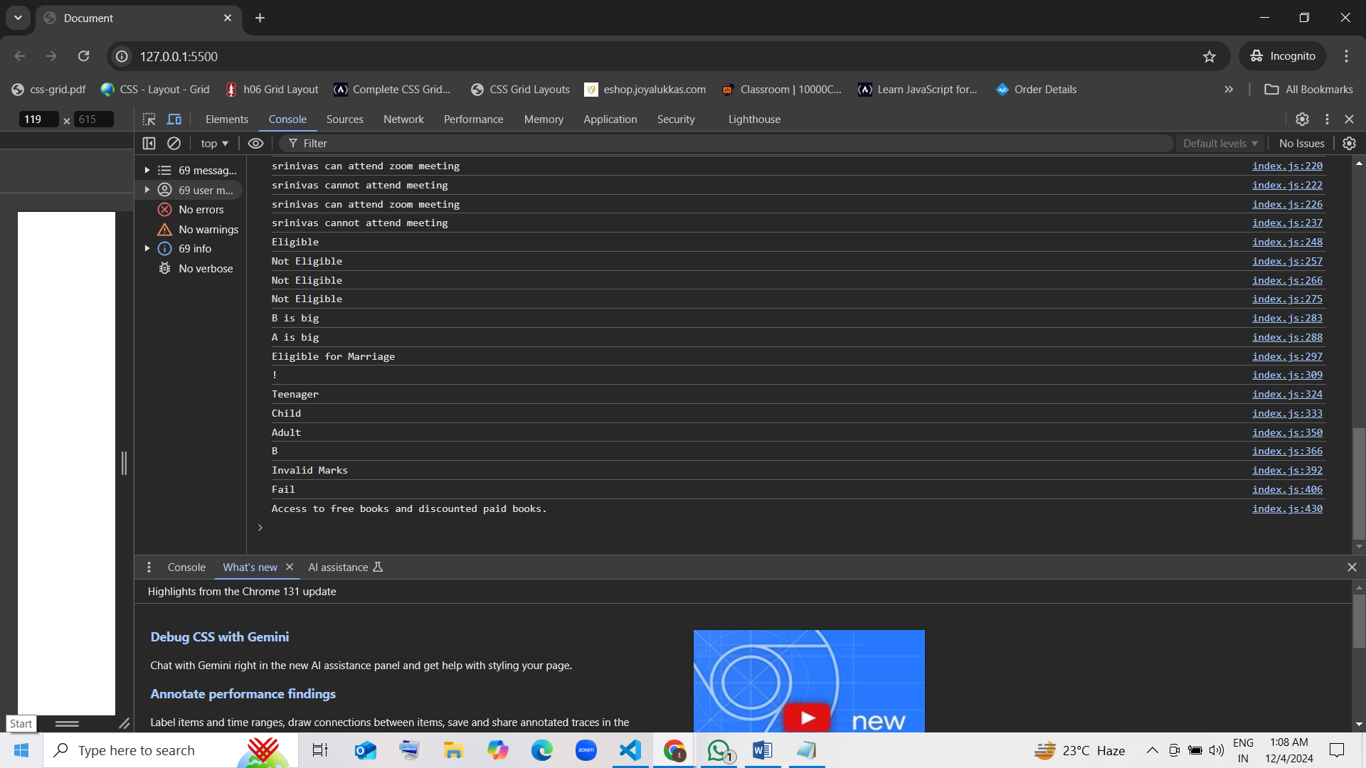

2. Scenario: E-Commerce Discount Application

Context: An e-commerce platform applies discounts based on the user's membership status and the total purchase amount:

Regular Customers: No discount for purchases under $100. A 5% discount for purchases between $100 and $500. A 10% discount for purchases over $500.

VIP Customers: A 10% discount for purchases under $100. A 15% discount for purchases between $100 and $500. A 20% discount for purchases over $500.

Question: Suppose you have variables that represent a user’s membership status and purchase amount. Use conditional statements to determine the final price after applying the appropriate discount. Think about how to handle invalid inputs, such as negative purchase amounts or unrecognized membership statuses.

3. Scenario: Academic Scholarship Eligibility

Context: A university offers scholarships to students based on their GPA and extracurricular involvement:

Merit-Based Scholarship: Requires a GPA of 3.5 or higher.

Leadership Scholarship: Requires active participation in at least two extracurricular activities and a GPA of 3.0 or higher.

Community Service Scholarship: Requires 100 or more hours of community service and a GPA of 2.5 or higher.

Question: Given variables that store a student's GPA, number of extracurricular activities, and community service hours, use conditional statements to determine which scholarships the student is eligible for. Consider scenarios where a student qualifies for multiple scholarships or none.

var studentGPA = 3.6;

var extracurricularActivities = 3;

var communityServiceHours = 120;

if (studentGPA >= 3.5) {

  console.log("Eligible for Merit-Based Scholarship.");

}

if (studentGPA >= 3.0 && extracurricularActivities >= 2) {

  console.log("Eligible for Leadership Scholarship.");

}

if (studentGPA >= 2.5 && communityServiceHours >= 100) {

  console.log("Eligible for Community Service Scholarship.");

}

if (studentGPA < 2.5 && extracurricularActivities < 2 && communityServiceHours < 100) {

  console.log("Not eligible for any scholarships.");

}

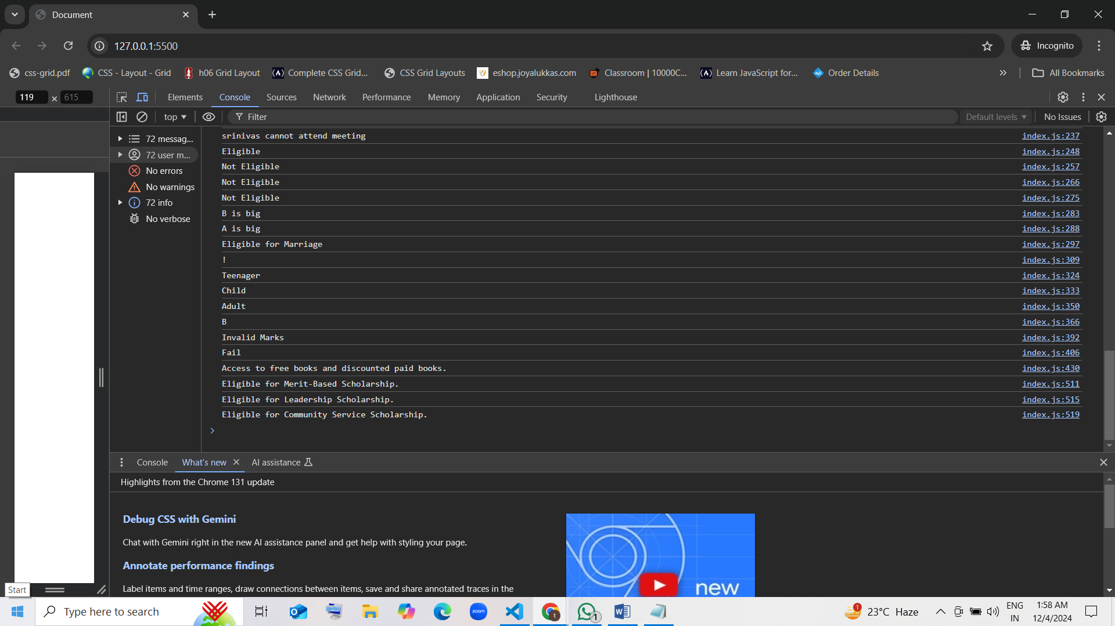

4. Scenario: Movie Ticket Pricing

Context: A movie theater charges different prices based on the day of the week and the customer's age:

Weekdays: Standard price of $12. Seniors (65 and older) and children (under 12) receive a 50% discount.

Weekends: Standard price of $15. Seniors and children receive a 30% discount.

Question: Assume you have variables for the day of the week and the customer’s age. Use conditional statements to determine the correct ticket price. Consider how to handle situations where the day or age is invalid.

var dayOfWeek = "Saturday";

var age = 10;

if (age < 0 || age > 120) {

  console.log("Invalid age. Please enter a valid age.");

} else if (dayOfWeek === "Monday" || dayOfWeek === "Tuesday" || dayOfWeek === "Wednesday" ||

           dayOfWeek === "Thursday" || dayOfWeek === "Friday") {

  if (age < 12 || age >= 65) {

    console.log("Ticket price: $6.00 (50% discount)");

  } else {

    console.log("Ticket price: $12.00");

  }

} else if (dayOfWeek === "Saturday" || dayOfWeek === "Sunday") {

  if (age < 12 || age >= 65) {

    console.log("Ticket price: $10.50 (30% discount)");

  } else {

    console.log("Ticket price: $15.00");

  }

} else {

  console.log("Invalid day of the week. Please enter a valid day.");

}

5. Scenario: Event Registration Validation

-------------------------------------------

Context: An event registration system needs to validate user inputs before confirming their registration:

The user must be 18 years or older to register.

The event allows a maximum of 100 participants. If the event is full, no more registrations are accepted.

The user must provide a valid email address.

Question: You have variables for the user’s age, the number of participants already registered, and their email address. Use conditional statements to validate whether the user can register for the event. Think about how to handle cases where some or all conditions are not met.